Project Design Phase-II
Technology Stack (Architecture & Stack)

Date | 25 September 2026
Team ID | SWTID-2026-4296
Project Name | AI StudyBuddy
Maximum Marks | 4 Marks

Technical Architecture:

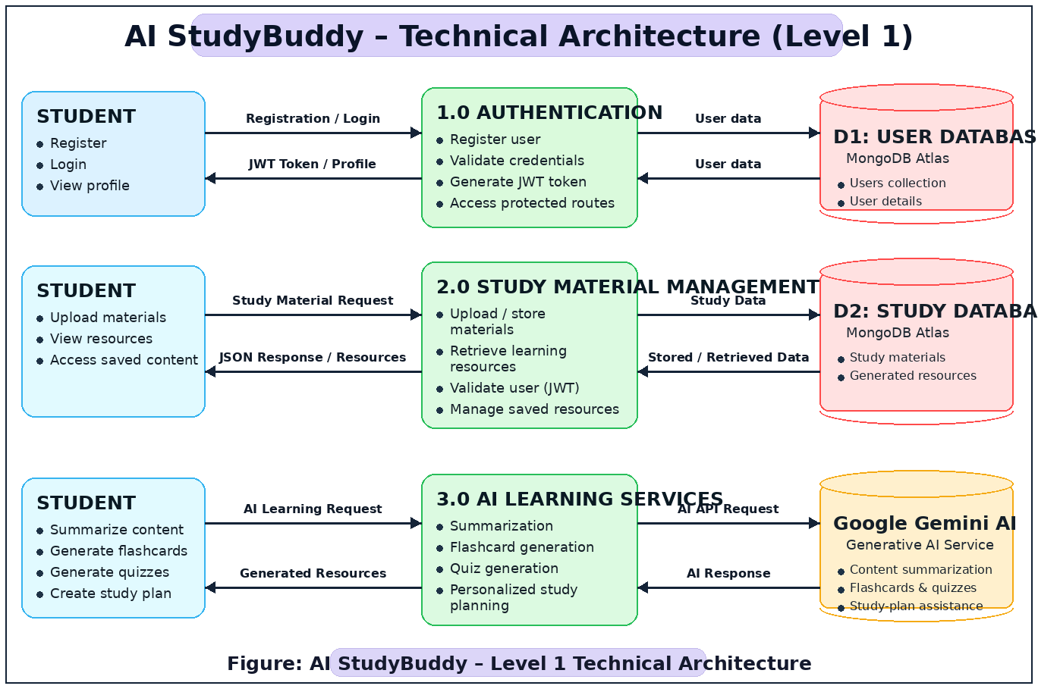

Table-1 : Components & Technologies:
S.No | Component | Description | Technology
 | User Interface | Interface used to send and test API requests | Postman / Thunder Client
 | Application Logic-1 | Handles REST API routing and server-side application logic | Node.js + Express.js
 | Application Logic-2 | Handles user authentication and authorization | JWT + bcrypt + Express Middleware
 | Application Logic-3 | Handles AI blog generation and content summarization | Google Gemini AI + Gemini Service
 | Database | Stores user and blog information | MongoDB + Mongoose
 | Cloud Database | Database Service on Cloud | MongoDB Atlas
 | File Storage | File storage requirements | Not applicable – current system stores structured data in MongoDB
 | External API-1 | Generates blog content and summarizes content | Google Gemini API
 | External API-2 | Additional external API | Not applicable in current version
 | Machine Learning Model | AI-based content generation and summarization | OGoogle Gemini Generative AI – external AI service
 | Infrastructure (Server / Cloud) | Application execution and deployment environment | LoLocal Node.js Server + MongoDB Atlas + Gemini Cloud Service

Table-2: Application Characteristics:
S.No | Characteristics | Description | Technology
 | Open-Source Frameworks | LBackend framework and supporting open-source packages are used to build the REST API | TNode.js, Express.js, Mongoose, Express Validator, CORS, Morgan, dotenvnsource framework
 | Security Implementations | Authentication, password protection, request validation and secure environment configuration | JWT, bcrypt, Express Validator, environment variables, CORS
 | Scalable Architecture | Modular MVC-based architecture separates routes, controllers, models, middleware and AI services | TNode.js, Express.js, MongoDB, Mongoose
 | Availability | Application depends on the availability of the local backend, MongoDB Atlas and Gemini service | Node.js Server, MongoDB Atlas, Google Gemini API
 | Performance | Lightweight REST/JSON communication and database-based operations reduce unnecessary processing | Express.js, MongoDB/Mongoose, JSON API

References:
https://c4model.com/
https://developer.ibm.com/patterns/online-order-processing-system-during-pandemic/
https://www.ibm.com/cloud/architecture
https://medium.com/the-internal-startup/how-to-draw-useful-technical-architecture-diagrams-2d20c9fda90d

